**Creating the DB in MySQL**

**(transaction_info)**

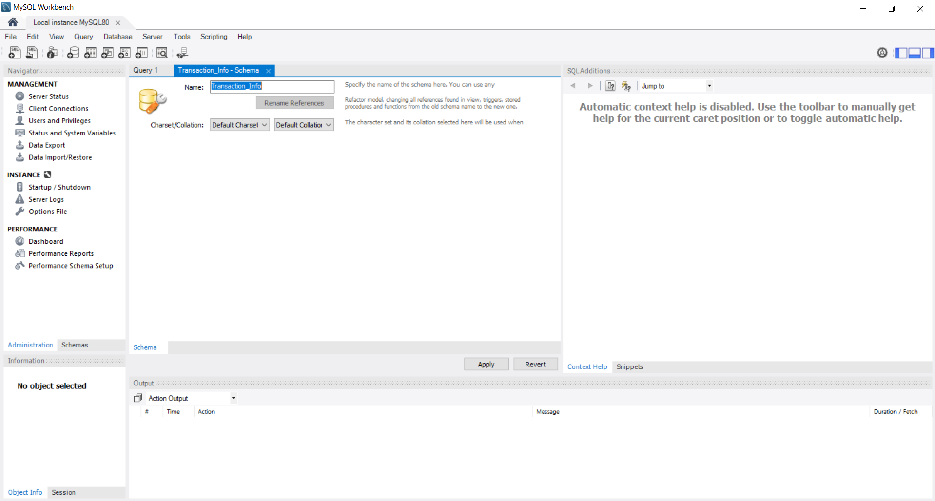

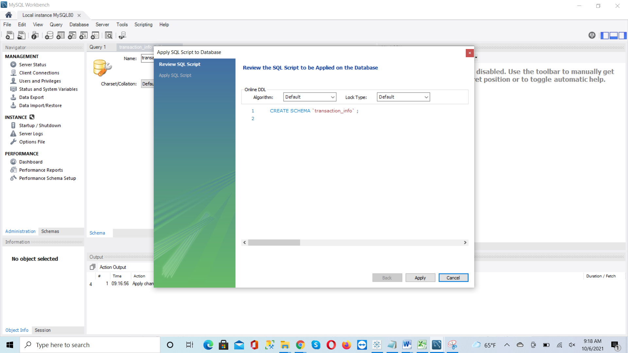

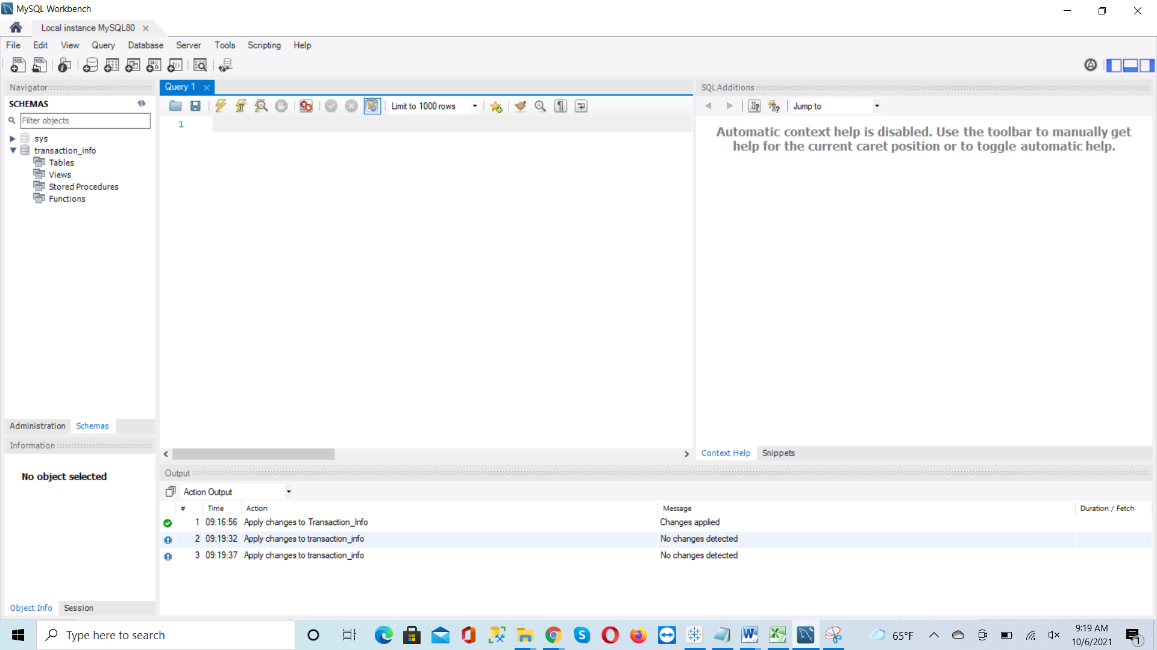

**Create tables:**

**(account_info)**

CREATE TABLE `transaction_info`.`account_info` (

`first_name` VARCHAR(100) NOT NULL,

`last_name` VARCHAR(100) NOT NULL,

`street_address` VARCHAR(200) NOT NULL,

`unit` VARCHAR(100) NULL,

`city` VARCHAR(100) NOT NULL,

`state` VARCHAR(100) NOT NULL,

`zipcode` VARCHAR(100) NOT NULL,

`dob` DATE NOT NULL,

`ssn` VARCHAR(50) NOT NULL,

`email` VARCHAR(100) NOT NULL,

`mobile_number` VARCHAR(100) NOT NULL,

`account_number` VARCHAR(100) NOT NULL,

PRIMARY KEY (`account_number`));

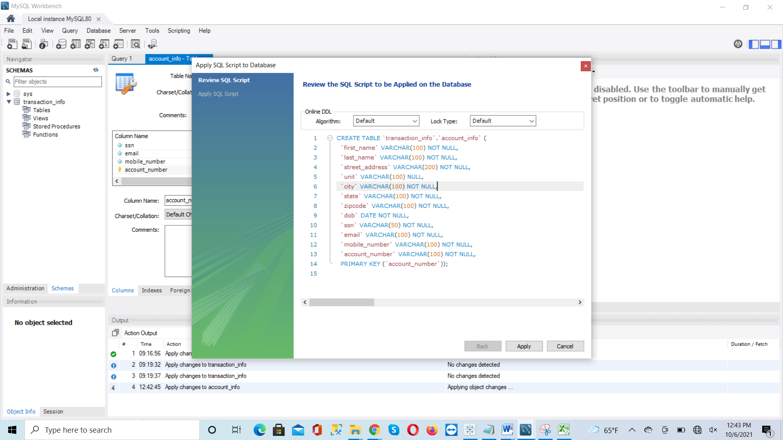

**To change the dob column Date type from date to VARCHAR(50):**

ALTER TABLE `transaction_info`.`account_info`

CHANGE COLUMN `dob` `dob` VARCHAR(50) NOT NULL ;

**Second Table:**

**(transaction)**

CREATE TABLE `transaction_info`.`transaction` (

`account_number` VARCHAR(100) NOT NULL,

`merchant` VARCHAR(100) NOT NULL,

`merchant_category_code` VARCHAR(100) NOT NULL,

`merchant_number` VARCHAR(100) NOT NULL,

`post_date` VARCHAR(100) NOT NULL,

`transaction_amount` FLOAT NOT NULL,

`transaction_date` VARCHAR(100) NOT NULL,

`transaction_number` INT NOT NULL,

`transaction_state` VARCHAR(100) NOT NULL,

PRIMARY KEY (`account_number`, `transaction_number`),

CONSTRAINT `transaction_account_FK`

FOREIGN KEY (`account_number`)

REFERENCES `transaction_info`.`account_info` (`account_number`)

ON DELETE NO ACTION

ON UPDATE NO ACTION);

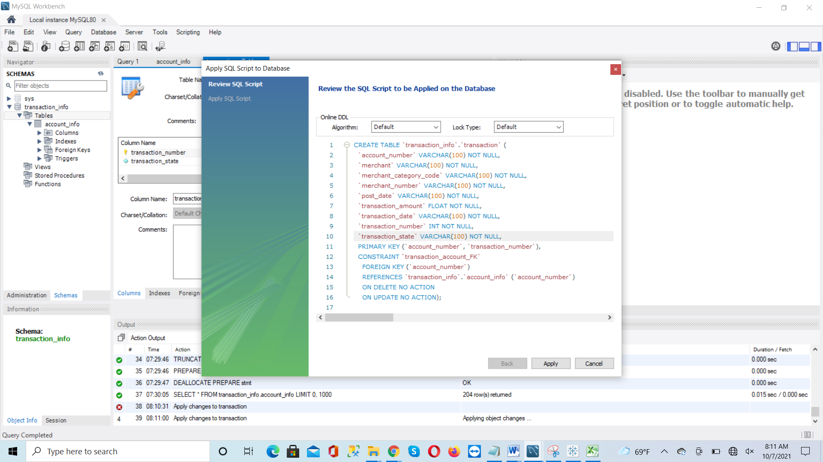

**Rule#2:**

use transaction_info;

SELECT acc.first_name, acc.last_name, acc.account_number,acc.state as

Expected_Transaction_Location, tr.transaction_number, tr.transaction_state as

Actual_Transaction_Location

FROM account_info acc inner join transaction tr on acc.account_number = tr.account_number

WHERE acc.state <> tr.transaction_state;

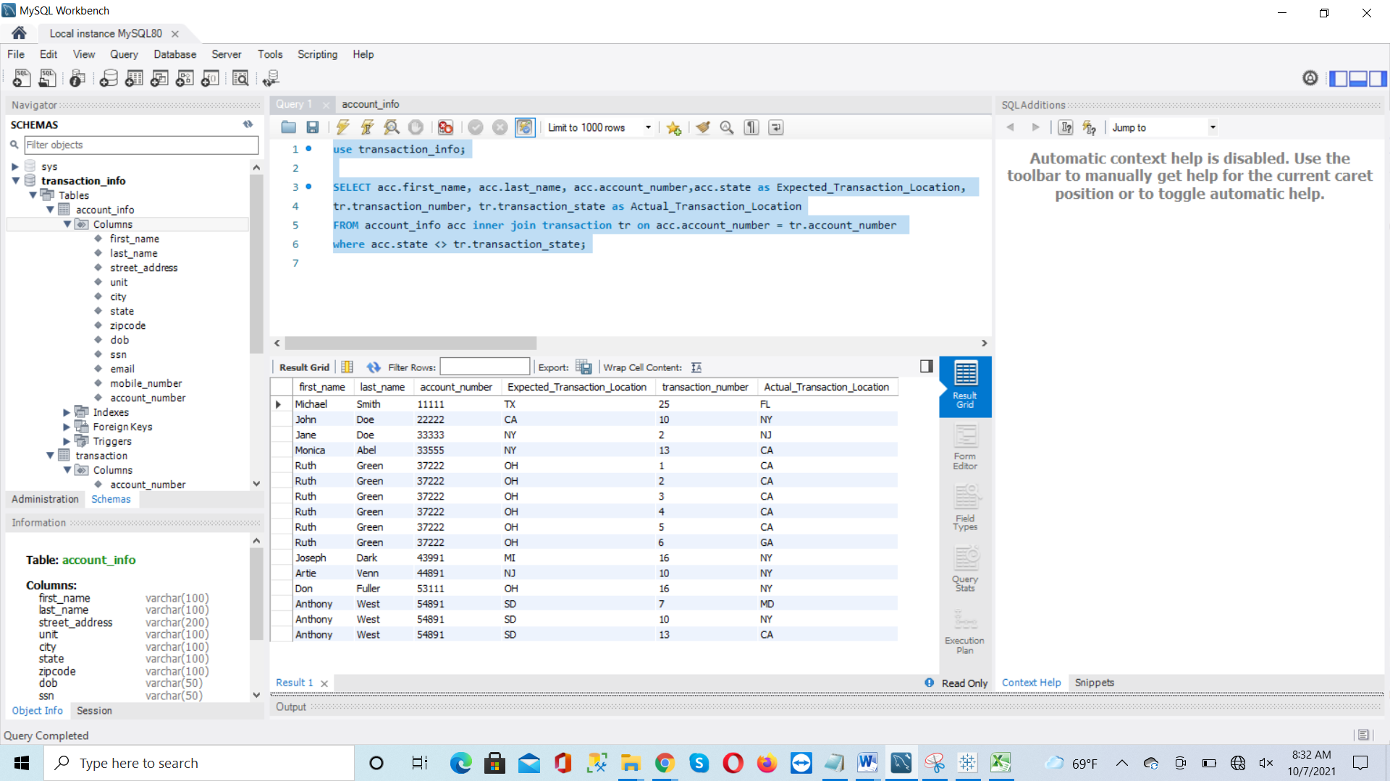

**Creates View for Z-Score:**

**(View: process_zscore)**

CREATE VIEW transaction_info.process_zscore as

SELECT tr.account_number, tr.merchant, tr.transaction_number, tr.transaction_amount,

AVG(tr.transaction_amount) as avg_transaction, STD(tr.transaction_amount) as

stdev_transaction, if (STD(tr.transaction_amount)<>0, (transaction_amount –

AVG(tr.transaction_amount))/ STD(tr.transaction_amount), 0) as z_score

FROM transaction tr GROUP BY tr.merchant, tr.account_number;

**Screenshot for the view:**

SELECT * FROM transaction_info.process_zscore;

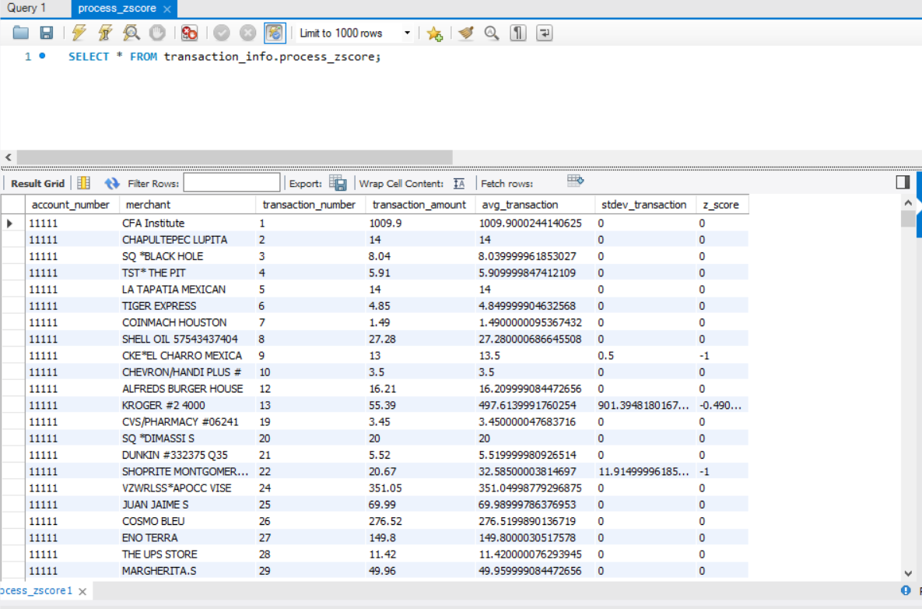

SELECT * From process_zscore where z_score <> 0;

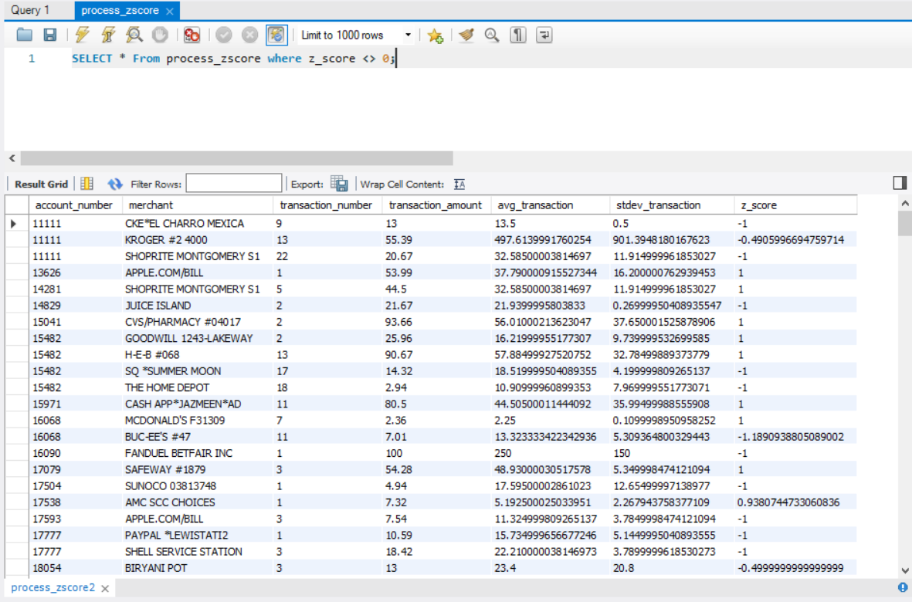

**Create z-score with account information:**

**(View: process_zscore_account)**

use transaction_info;

CREATE VIEW transaction_info.process_zscore_account as

SELECT CONCAT(CONCAT(acc.first_name, " "), acc.last_name) as customer_name,

zs.transaction_number, acc.account_number, zs.merchant, zs.transaction_amount,

zs.z_score

FROM account_info acc inner join process_zscore zs on

acc.account_number = zs.account_number

**Screenshot for the two views created:**

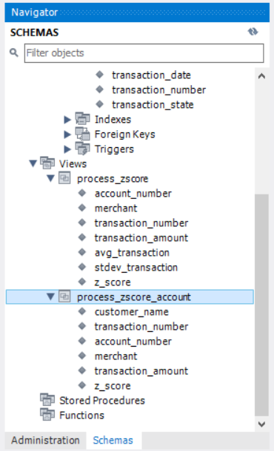

**Pulling out data from the view:**

SELECT * FROM transaction_info.process_zscore_account where z_score>1 || z_score<-1;

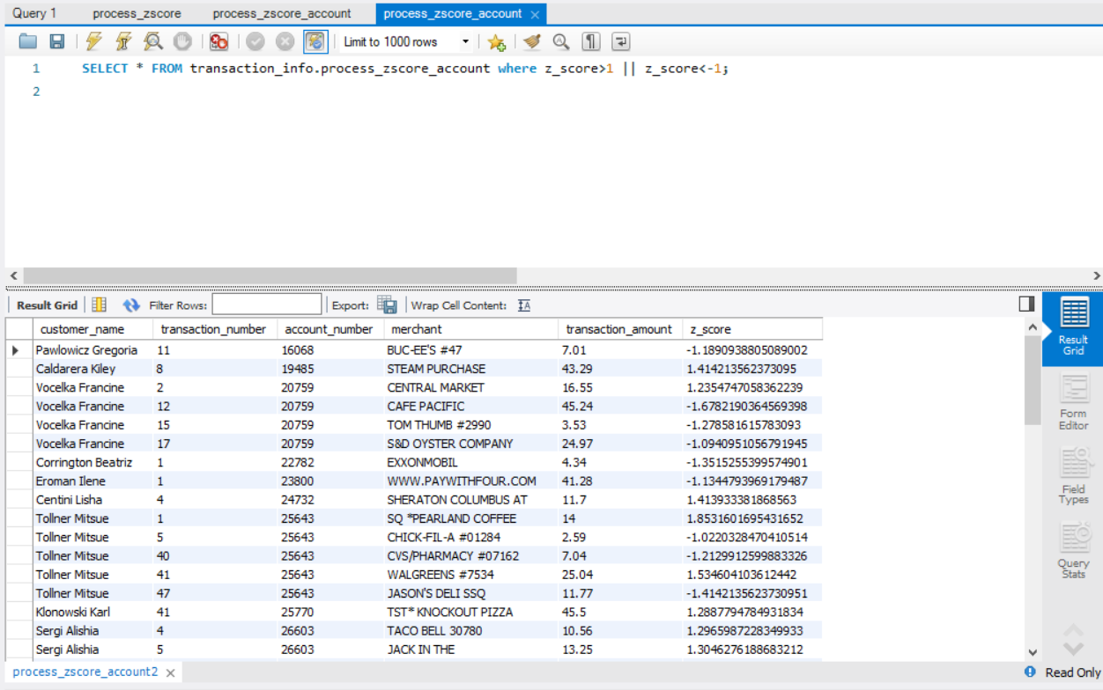

SELECT * FROM transaction_info.process_zscore_account where z_score>2 || z_score<-2;

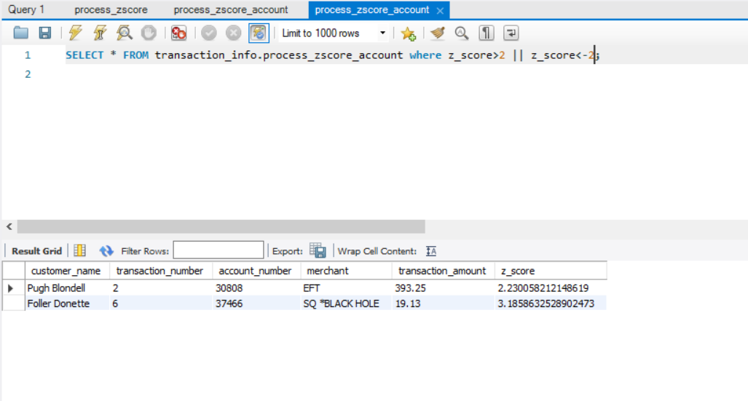

**RULE #1:**

SELECT customer_name,transaction_number, account_number, merchant,

CONCAT("$",transaction_amount) as transaction_amount, z_score

FROM transaction_info.process_zscore_account where z_score>2 || z_score<-2;

**Screenshot:**

